Name : Vivek Singh
RegNumber : 230905408
Roll Number: A50

Lab 7: Programs on Strings in CUDA

Q1).
Code:
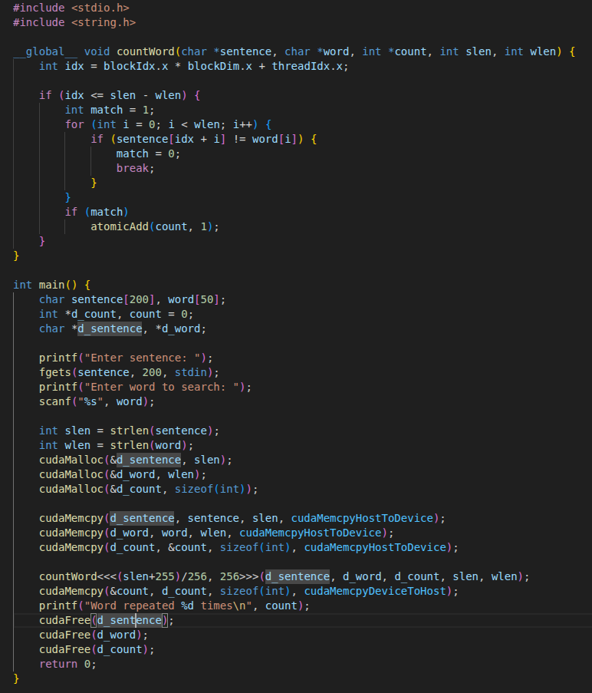

Output :

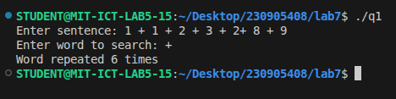

Q2)
Code:
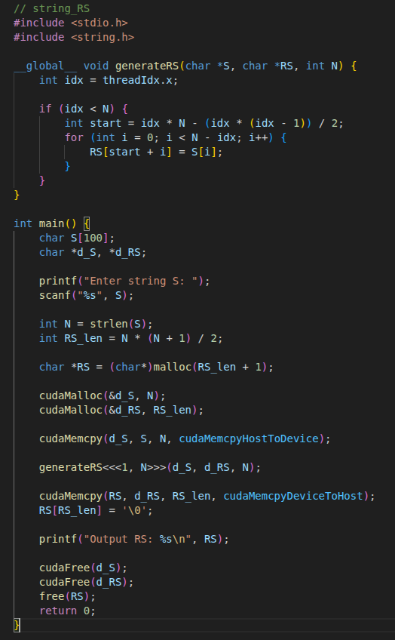
Output:

